|  |  |
| --- | --- |
| Sector Code : | Day Month Year |
| Applicant: □ Federal 　 Ministry of   * Province （□ Baluchistan □ NWFP □ Punjab □ Sind ）   　　　　　　　　　　Department of | |
| Implementing Agency: NED University of Engineering & Technology, Karachi, Pakistan.  Address: Computer systems & Information Engineering Department, NED University of Engineering & Technology.  Contact Person: **Dr. Muhammad Khurram**  Tel.No.: 021-99261261-68Ext:2287　 Mobile.No: 0335-3046110 　　　　　　　Fax. No :  E-Mail: [mkhurrum@neduet.edu.pk](mailto:mkhurrum@neduet.edu.pk) | |

**APPLICATION FORM**

**FOR**

**JAPAN’S “*TECHNICAL COOPERATION*”, “*DEVELOPMENT STUDY*”**

**AND “*GRANT AID\**”**

**\*　”Grant Aid General”, “Grant Aid Fisheries” and “Grant Assistance for under Privileged Farmers”**

< INSTRUCTIONS >

* Please fill in this application form concisely.
* Only required documents (Approved CCP/PC-1/PC-2, Maps, Organization Chart and so on) will be appreciated to be attached to this application form.

**1.　Project Title**

**STATE OF THE ART COMPUTING SYSTEM DEPLOYMENT TO IMPROVE AGRICULTURAL SECTOR OF PAKISTAN**

**2.　 Procedural status in Pakistan Government**

**Please check box**.

　□　Approved　（　□　Concept Clearance Paper　□　PC-1　　□　PC-II　）

( □　DDWP □ CDWP □ ECNEC )

　□　Under preparation of CCP

* Part of the approved project

( □　listed in PSDP/ADP or □ not listed in PSDP/ADP)

(Project name: )

□ Part of the 5 / 10 Year Plan or Medium Term Development Framework

□　Small and no need CCP/PC-I/PC-II process

**3.　Site location**

**Please attach a rough map with this form. The map should be at a scale that clearly shows the study/project site. Mark the site.**

[**https://www.google.com/maps/place/NED+University+of+Engineering+and+Technology/@24.932401,67.112738,17z/data=!3m1!4b1!4m2!3m1!1s0x0:0xf864ed97b4a8ec0e**](https://www.google.com/maps/place/NED+University+of+Engineering+and+Technology/@24.932401,67.112738,17z/data=!3m1!4b1!4m2!3m1!1s0x0:0xf864ed97b4a8ec0e)

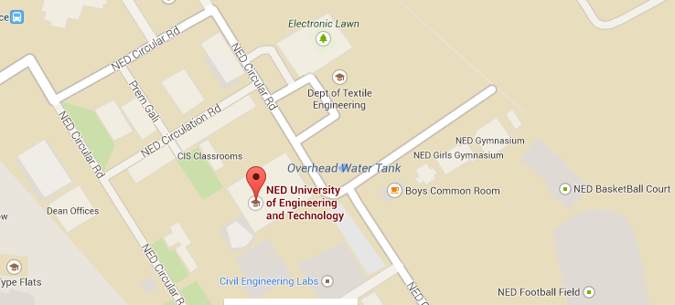

**4.　Background of the Project**

**( 1 ) Current condition of the sector**

A huge portion of Pakistan’s economy is dependent on the agricultural sector; 50% of the total population relies on farming & cultivation for their income. Nowadays the agriculture sector is encountering numerous major problems and its growth rate decreasing every year which results declining in GDP. In 1947, 53% of the total GDP of Pakistan was based on agriculture but unfortunately today it contributes only 23% [1] [2]. The reason for such a rapid downfall is that the crops and fields are not monitored properly. There is need to apply scientific technology as other countries are adopting worldwide. In Pakistan still old traditional ways of farming are in practice, farmers solely use his experience to look after his fields Water availability is the major factor to increase productivity in agriculture sector. Currently the archaic method of irrigation which is in practice all over the country wastes almost 50% - 60% of Pakistan’s water resources [3] [4]. Since fresh water resources are already scarce in Pakistan so there is need to propose technology based solutions of irrigation which utilized water in efficient manner.

**( 2 ) Issues and problems to be solved**

Agriculture sector uses 85% of available freshwater resources worldwide, most of which are gone wasted. If the amount of water continues to be utilized by the agriculture sensor, this may poses a serious threat to the water resources. The population is growing rapidly, food and water demands are also increasing [9] meanwhile fresh water resources are decreasing, and therefore it is required to make the efficient use of water on the first priority [10]. There is an urgent need to create strategies based on science and technology for sustainable use of water [11] [12]. Smart irrigation system using state of the art computing technologies for agri area of Pakistan has been designed to counter/target the following issues and problems faced by the Agriculture sectors:

* Lack of quality labor in the agriculture field leads to low production. State of the art computing systems for agri area of Pakistan offers an observable and controllable system with which it would be possible to keep track of the field as well as the labor.
  + - It is very important in farming to determine, at what time, what amount of water is required by the crops. The main focus of this project is to provide controlled and timely distribution of water in the fields.
    - Currently, there are no field monitoring systems available in Pakistan which could monitor a vast area/field. This project is scalable, efficient & can easily provide coverage to a large area.
    - Water resources are reducing each passing year. Crops suffer badly due to lack of fresh water. In advance stage of this project we can find in advance the amount of water required in different areas and seasons. It will help framers to take appropriate decisions about cultivating new crops.

**( 3 ) Related Government’s policy**

**(National/Provincial Development Plan & Sector Development Plan)**

Agriculture and food security form are key elements of the Government's planning. According to the Framework for Economic Growth, "Vision 2030", the Medium Term Development Framework and the Poverty Reduction Strategy Paper II (PRSP-II) pay major attention on the role of agriculture. However, these plans can and should not be considered a substitute sufficient for comprehensive agricultural policy. Agriculture Policies for Growth and Poverty Alleviation and Programs Government of Pakistan through irrigation efficiency has following main components [11]:

• Water use efficiency by lining water courses   
 • Judicious use of surface and well water tube   
 • Employment farmer organizations   
 • Increased public investment   
 • Experiment with sprinkle and drip irrigation

In Pakistan Government policy, Irrigation scheme generally includes the following components:

*Raising the irrigation water from the natural nallahs and low water ponds by pumping devices   
      *Transport the water to the fields located at higher elevations through GI and PVC pipes   
      *Water supply to areas of lower or equal elevation through open channels   
      *Connect various areas in three RCC depressions or PVC pipes   
      *Nakkas and provide turnouts at water distribution points

**The government of Punjab province is taking interest in high efficiency irrigation systems like “drip irrigation” and “sprinkle irrigation”. They also wanted to convert these irrigation systems which are powered by solar energy to save electricity.**

**( 4 ) Other relevant projects or activities for solving said issues and problems**

## 2.2: USAID Initiatives for development in Agriculture Sector of Pakistan

USAID is an independent agency of the US. Government that provides economic development and humanitarian assistance around the world in support of the foreign policy goals of the United States. According to USAID report related to “Pakistan food and agriculture systems” highlighted main reason for degradation of agriculture sector is not adopting new technology, low investment in research and development, in developing or disseminating higher production packages, in maintaining an effective agricultural education and extension system, and in maintaining physical infrastructure. USAID has started many projects related to agriculture some of them are following [6-8]:

* **USAID & ASF Launch Agribusiness Project**

The five-year Agribusiness Project is funded by the American people through USAID and is implemented by ASF. The project aims to address priority constraints impeding the development of Pakistan’s agriculture sector with a focus on horticulture and livestock sub-sectors. (2009-on going)

* **USAID Pakistan, Irrigation Support Project for Asia and Near East**

Participated in the evaluation of the Command Water Management Project. (August-September 1988).

* **USAID/Pakistan buy-in, Agricultural Policy Analysis IQC (subcontracted by Abt Associates)**

In collaboration with the Harvard Institute for International Development, completed policy studies on edible oils and livestock feed, and background studies on rural land and labor markets, and the sources of agricultural productivity. (1990-1992)

* **USAID/Pakistan Agricultural Research Council/Abt Associates, Agricultural Policy Analysis and Teaching Workshop** (December 1991-January 1992).
* **USAID Mission in collaboration with EDC in Pakistan**

EDC was one of seven firms selected by the mission to provide M&E services to USAID Pakistan in the areas of health, education, economic growth, and democratic governance. (2004-2006)

* **USAID, Irrigation Support Project for Asia and the Near-East**

For Pakistan country, study of the environmental sustainability of urban-rural water resource development and management (Faisalabad District as a case study). (April-May 1993)

**5. Outline of the Project**

**( 1 ) Overall Goal / Longterm-term objective**

* The quality of labor at work in the agricultural fields is poor due to lack of technical education, incentives and facilities This project will help in monitoring the crops by the workers during every day, tasks in large areas which could not be accessed easily otherwise.
* It would enhance the quality of work on the field and could increase the yield of the crop.
* This project will also target remote monitoring of the crops against the attack of any pest or plant decease. It would allow the farmer to take timely actions to save the plants from such attacks.
* The project’s objective would contribute to increase agriculture production, employment and incomes, higher living standards and positive environmental outcome. Water reservoirs in Pakistan are being utilized at a very fast pace. The lack of dams and other reservoirs results in drought; this not only destroys the green fields and livestock but also threat to human lives. The construction of new dams/reservoir needs a lot of investment and time, therefore the only hope of salvation is save whatever water resources have been left. This triggers the necessity of saving water; this can be achieved by the use of digital & precise auto-irrigation or State of the art computing systems for agri area of Pakistan system. Water reservoirs in Pakistan are being utilized at a very fast pace. The lack of dams and other reservoirs results in drought; this not only destroys the green fields and livestock but also threat to human lives.
* Water reservoirs in Pakistan are being utilized at a very fast pace. The lack of dams and other reservoirs results in drought; this not only destroys the green fields and livestock but also threat to human lives. The construction of new dams/reservoir needs a lot of investment and time, therefore the only hope of salvation is save whatever water resources have been left. This triggers the necessity of saving water; this can be achieved by the use of digital & precise auto-irrigation or smart irrigation using State of the art computing technologies for agri area of Pakistan.
* Another objective of this project is to design a system which would detect the crop’s quality that whether crop is healthy or not. It has also been planned to implement a monitoring system which would be using Artificial Intelligence as its main tool, this feature maybe used to predict the seasonal affects etc. it is intended to the make the system intelligent enough to take decision on its own and perform timely actions.

The project’s objective would contribute to increase agriculture production, employment and incomes, higher living standards and positive environmental outcome.

**( 2 ) Project Purpose / Short-term objective**

The short-term objective of this project is to design a smart irrigation system using state of the art computing technologies, which would benefit the agricultural sector of Pakistan. The intent of this application is to get information from the Wireless Sensor Network (WSN) that employs various sensor networks to acquire various environmental parameters from the field to automate the irrigation process.By applying this system water wastage can be greatly reduced in great manner on the other hand electricity can be saved through power harvesting and produce healthy production of crops.

**( 3 ) Output**

The final output of this proposed system will be fully functional intelligent automatic irrigation system with smart sensing behavior. This will be very economical in terms of cost of equipment.

**( 4 ) Project Activities**

**If this project is “Development Study”,please fill in the “Scope of the Study” and**

**“Study schedule”, here.**

**Scope of Study:**

Development of agriculture requires promising technologies and innovations that result in farm productivity .It would vastly increase the production of the field where this product is implemented. Basically the increase in production means less investment of materials, saving of resources and time with greater output.

Specifically the scope of study includes:

1. WSN(Wireless Sensing Node)
2. Intelligent control system
3. Power Harvesting
4. Internet of Things

Although they comprehensively described in the proposal attached, moreover only a brief view these studies are discussed here:

Wireless sensors spread over a vast area collect water requirement from different areas of field wirelessly and send them to their respective acquisition and control unit where the water pumps are activated depending upon the requirement. The activity log is updated on server. The system can be operated manually by any handheld device by the use of state of the art technology “Internet of Things”.

**Study Schedule:**

After preliminary study, we have planned to implement initial prototype module within six month for small field area. Which consist of wireless sensing network (WSN), data processing and control unit modules. After that we move to automate irrigation system to distribute water in selected areas.

**( 5 ) Beneficiaries**

**Pleas identify the beneficiaries and population for which positive change are**

**intended directly and indirectly by implementing the project, and gender**

**disaggregated date, if available.**

Nowadays the efficient use of fresh water is a burning need in Pakistan, therefore efficient and intelligent irrigation management is a major concern in agriculture. Working on designing an intelligent irrigation system is to target labor and water saving [6] [7]. The following are the direct and in direct beneficiaries of this system:

* Farmers
* Common people
* Traders
* Industrialist
* Provincial Government and Government of Pakistan

The proposed system is an application of modern technology which is being implemented worldwide. State of the art computing systems for agri area of Pakistan is likely expected to provide a boost in agricultural sector of Pakistan fresh water is required by each individual of Pakistan therefore the water saved through this project would be indirectly utilized by the individuals. The Overall beneficiaries of this project will be the individuals living in the country.

**( 6 ) Related Activities (Other donors and NGOs)**

**( 7 ) Input from the Pakistan side (Arrangement done by Pakistani side as its**

**responsibility)**

**1) Counterpart personnel and support staff attached to the project (Number**

**and Position)**

Computer Systems & Information Engineering (CIS) department of NED University works in collaboration with The Koshish Foundation to carry out this project. The execution of this project is in initial phase accompanied by literature survey & project proposals.

**2)**　**Available office space, vehicles, equipment and etc.**

CIS is providing lab space with limited support of computers, internet and non-technical staff for maintenance.

**3)**  **Running expenses (allocation in PSDP or ADP)**

**4) Available data, information, documents, maps, etc**

Please see attached detail proposal.

**5) (If this project is “Grant Aid”) Cost of equipment purchase or facility**

**construction with its breakdown**



**( 8 ) Input from the Japanese side ( Request to Japanese side from Pakistani side)**

**1)**  **Experts (Number, Field and qualification)**

**Please check box.**

NOT NECESSARY

* YES　　　　　Field Number Qualification

Agriculture 2 MS/PHD

**２）Training, seminars and workshops (Expected participants and numbers)**

**Please check box**

　□　NOT NECESSARY

* YES, in Pakistan

　　　　　　　Participants Number

>500 4

YES, in Japan or third country

　　　　　　　Participants Number

**３） Equipment**

**Please check box**

　□　NOT NECESSARY

* YES

1. **Site address to be installed**

NED University of Engineering & Technology, Karachi, Pakistan.

**②Function of the equipment**

The equipment will be used to support the researchers and developers in their study, training, design, and development and in installation phases. The equipment mentioned above is essential for this project. Further details can be provided on demand. The equipment will be operated by the research and technical staff of the Department of Computer & Information Systems Engineering.

**③Name of main equipment’s**

1. Sensor Node
2. Server Node
3. Physical Body
4. Irrigation Equipment
5. Power Supply Units
6. Shipment Cost
7. Data center implementation

**④Cost of purchase (Cost breakdown)**



**⑤Specifications, the quantity, and unit price (if available)**



**⑥ Invoice (if available)**

**⑦ How to operate and maintain the facility, technical level of the**

**responsible organization and the staff.**

**For details please see attached document**

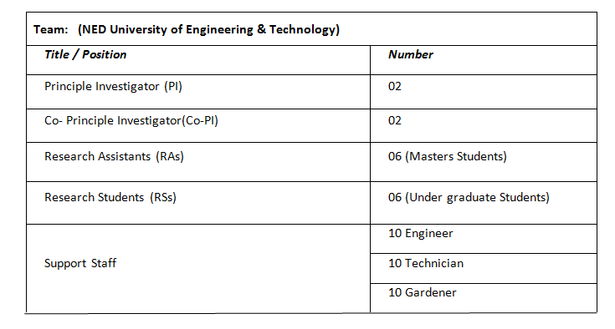

**⑧Amount of the equipment**

Total Amount (including the cost of Pakistan side)

**Rs. 518,001,000,000.00**

Request Amount（Please check box）

* Less than US$　5,000,000

　　 □　Between US$ 5,000,000 and US$ 10,000,000

　　 □　More than US$ 10,000,000

　 □　Rs.

**４）** **Facilities (Complete or partial building construction )**

　Please check box.

* NOT NECESSARY
* YES

**①Site address**

NED University of Engineering & Technology Karachi,Pakistan.

**②Rationale for the selected sites**

**If there are some candidate sites, please specify the priority of them.**

1. **The number and the size of the facility**

Number=1

Size: 600 Sq. yards

1. **Cost of construction (Cost breakdown )**

Land: 9000000

Construction: 9000000

**⑤Layout plan (if available)**

**⑥Specifications of construction materials (if available)**

**⑦How to operate and maintain the facility, technical level of the**

**responsible organization and the staff**

For details please see attached document.

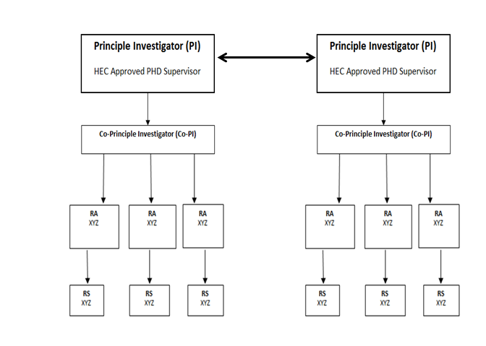

**⑧Amount of the facilities**

Total Amount (including the cost of Pakistan side)



Request Amount（Please check box）

* Less than US$　5,000,000

　　 □　Between US$ 5,000,000 and US$ 10,000,000

　　 □　More than US$ 10,000,000

　 □　Rs.

**( 9 ) (If this project is “Development Study”) The project’s priority in the National Development Plan**

Since Pakistan is an agricultural country and 60 % of the total revenue of Pakistan is from agriculture, therefore priority of this project in National Development Plan must me at top to give a splendid rise in Pakistan’s economy earned through agriculture. Agriculture automation has a wide range of benefits on the government sector level. Most of the crops are destroyed due to over watering of the fields and no proper soil posture. By introducing modern technologies in agriculture, better of farming will be implemented and more yield of crops is possible. Hence, this project has a great importance in the betterment and future of agriculture in Pakistan.

**( 10 ) (If this project is “Development Study”) Expected funding resource and/or assistance ( including external organization) for implementation of plans proposed by the Development Study**

|  |
| --- |
|  |

* Government of Pakistan
* ICT R&D

**6. Implementation Schedule**

**Month Year ~ Month Year**

August 2015 August 2019

**7. Implementing Agency**

**( 1 ) Attach an organization chart**

**( 2 )**　**Annual budget**



**( 3 ) Staffing (on a category basis)**

Please see this attached sheet.

**8.　Security Conditions**

No

**9.　Gender Consideration**

**No**

**10　Environment and Social Considerations**

**Please fill in the attached Screening Format**

The use of renewable energy source to power up the system will reduce the effect of global warming which is increasing day by day due to burning of fuel.

* Irrigation has contributed significantly to poverty alleviation, food security, and improving the quality of life for rural populations.
* By the saving of water the life of the Pakistani Nation would flourish.
* Water is applied in such a way that salt is not allowed to build up in the soil. The farmers would gradually interact with the project descriptors and eventually get educated about the project and its working. This way the farmers and the other individuals will be technically educated.

The State of the Art Computing Systems for Agri Area of Pakistan shall influence the following factors:

### 13.1.1 Poverty Eradication

The relative contribution of a sector to poverty reduction is shown to depend on its direct and indirect growth effects as well as its participation effect. The poor participate much more in growth in the agricultural sector, especially in low-income countries, resulting in much larger poverty reduction impact. Together, these findings support the overall premise that enhancing agricultural productivity is the critical entry-point in designing effective poverty reduction strategies. Yet, to maximize the poverty reducing effects, the right agricultural technology and investments must be pursued, underscoring the need for much more country specific analysis of the structure and institutional organization of the rural economy in designing poverty reduction strategies. Fig3 shows the trend of poverty population (percentage) vs. year.

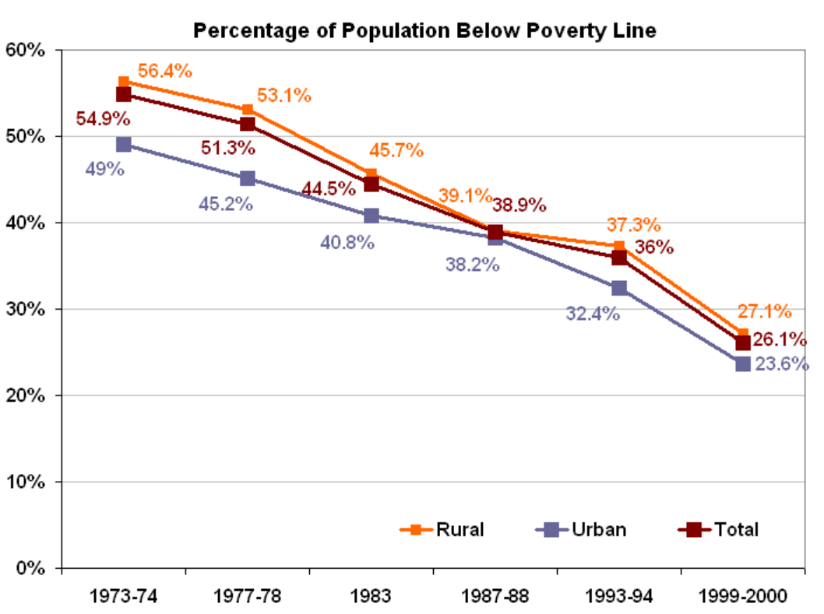

Fig3 Rural poverty in Pakistan

### 13.1.2 Agriculture Fights the Effects of Global Warming

Research shows that a healthy organic agriculture system can actually reduce carbon dioxide and help slow climate change. In fact, a research shows that:

"If only 10,000 medium sized farms in the US. Converted to organic production, they would store so much carbon in the soil that it would be equivalent to taking 1,174,400 cars off the road, or reducing car miles driven by 1462 billion miles"

### 13.1.3 Water Conservation and Water Health

Dwindling water supplies and poor water health are very real threats. When water supply is at risk, people and the planet end up suffering. Adverse environmental effects such as harmful pesticides, toxic fertilizers and animal waste results due to insensitive irrigation. This automatic irrigation system helps keep our water supplies clean by stopping that polluted runoff. It also helps to conserve water. Following graphs visualizes predicted trends and behavior of different effects over State of the Art Computing System Deployment to Improve Agricultural Sector of Pakistan by adoption of smart irrigation strategies.

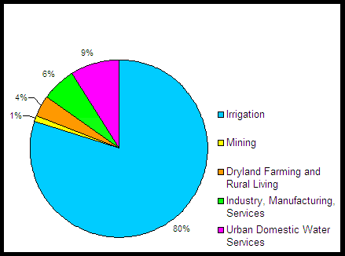

**Fig5 Water Usage without technological advancements**

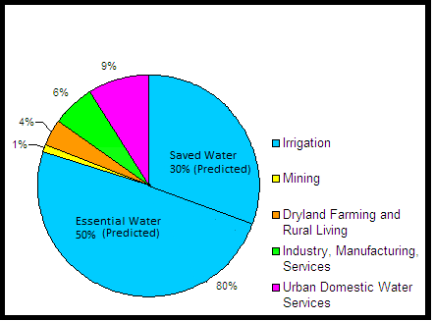

**Fig6 Water Usage with technological advancements**

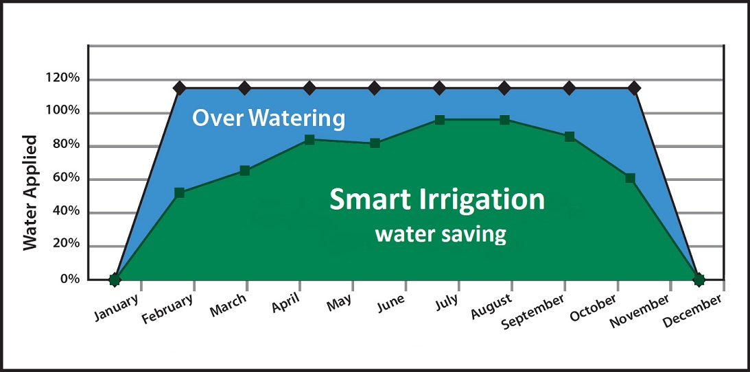

Figure7. predicted water saving by "Smart Irrigation” State of the Art Computing System Deployment to Improve Agricultural Sector of Pakistan

### 13.1.4 Social benefits to human resource

The technological transformation of traditional agriculture will be difficult without a matching effort to develop human resources; hence it becomes essential through educational reforms to produce researchers more attuned to the needs of rural peoples and agriculture becomes a need so that targeted human resources and the agriculture sector may mutually benefits. Illiteracy is still widespread among the rural poor. Efforts to promote literacy should focus attention on literature covering the efficient use of land, water, and forests.

Computation in the field of agriculture would not only attract investors but also common landholders to make use of their land which ultimately results in growth of agriculture in Pakistan. On the other hand, to benefit from new information and knowledge, new skill sets at various levels would promote people from different disciplines to enter the agriculture sector. These include (as examples):

* Scientists/Researchers and Research Managers
* Extension/Knowledge intermediaries
* Teachers
* New Farmer Entrepreneurs
* Agri-business Entrepreneurs
* Farmers

**13.1.5 Hands on exposure/Learning**

Agriculture is increasingly becoming more knowledge intensive with new research and development. Plenty of opportunities for hands-on research and learning, doing a directed research project, participate in hands-on labs, exposure to new software and hardware technologies would encourage new findings.

**11. Undertakings for the Study**

The Government of Pakistan assures that the matters referred to in this form will be ensured for the smooth conduct of the Development Study and the study for the Grant Aid Project by the Japanese Study Team.

(1) To facilitate the smooth conduct of the Study, the Government of Pakistan shall take necessary measures:

2) To exempt the member of the Team from taxes, duties and any other charges on equipment, machinery and other material brought into of Pakistan for the implementation of the Study;

1. To exempt the member of the Team from income tax and charges of any kind imposed on or in connection with any emoluments or allowances paid to the members of the team for their services in connection with the implementation of the Study,
2. To provide necessary facilities to the Study Team for remittance as well as utilization of the funds introduced in (the recipient country) from Japan in connection with the implementation of the Study,

(2)　The Government of Pakistan shall bear claims, if any arise against the member(s) of the Team resulting from, occurring in the course of, or otherwise connected with the discharge of their duties in the implementation of the Study, except when such claims arise from gross negligence or willful misconduct on the part of the team.

(3) The Implementing Agency shall act as counterpart agency to the Japanese Study Team and also as coordinating body in relation with other governmental and non-governmental organizations concerned for the smooth implementation of the Study.

1. The Implementing Agency shall, at its own expenses, provide the Team with the following, in cooperation with other organizations concerned.

1) Security-related information on as well as measures to ensure the safety of the team;

2) Information on as well as support in obtaining medical service;

3) Available data and information related to the Study;

4) Counterpart personnel;

5) Suitable office space with necessary office equipment and furniture;

6) Credentials or identification cards; and

7) Vehicles with drivers

(5) The Implementing Agency will, as the executing agency of the project, take responsibilities that may arise from the products of the Study. *In the case that Detail Design Study is requested.

**13. Others**

**References**

[1]:http://en.wikipedia.org/wiki/Economy_of_Pakistan

[2] http://en.wikipedia.org/wiki/Agriculture_in_Pakistan

[3]: Muhammad Iqbal and Munir Ahmad” SCIENCE & TECHNOLOGY BASED AGRICULTURE VISION OF PAKISTAN AND PROSPECTS OF GROWTH “

[4]:Fawad Zafar Ahmad Khan, Muhammad Sagheer,Mansoor ul Hasan,Hafiza Tahira Gul,Feehan Hassan,Syed Amir Manzoor,Atif Wahid” GRICULTURAL DYNAMICS IN PAKISTAN: CURRENT ISSUES AND SOLUTIONS” Russian Journal of Agricultural and Socio-Economic Sciences, 8(20) 2013.

[5]: Joaquín Gutiérrez, Juan Francisco Villa-Medina, Alejandra Nieto-Garibay, and Miguel Ángel Porta-Gándara” Automated Irrigation System Using a Wireless Sensor Network and GPRS Module” IEEE TRANSACTIONS ON INSTRUMENTATION AND MEASUREMENT, VOL. 63, NO. 1, JANUARY 2014.

[6]:development of research programme in Pakistan related to irrigation and drainage by Food and Agriculture Organization of the United Nations(FAO).ftp://ftp.fao.org/agl/iptrid/PFR_9.pdf.

[7]:http://www.who.int/water_sanitation_health/takingcharge.html.

[8]:Ali AL-HAMDI, Muhammad AKRAM, Ahmed Monjurul HASAN”Development of an ICT-based layer model for improving managerial decision making on water issuesin arid and semi-arid regions” International Journal of Computer and Information Technology (ISSN: 2279 –0764) Volume 01–Issue 02, November 2012.

[11]:http://siteresources.worldbank.org/INTPAKISTAN/Resources/Presentation-By-Ismail-Quershi-Sec-MINFAL.pdf